1. Please download and install PDFgui 2.0, the Python 3 version of the PDFgui software.
   1. Please go to diffpy.org
   2. Navigate to PDFgui
   3. Follow the installation instructions. 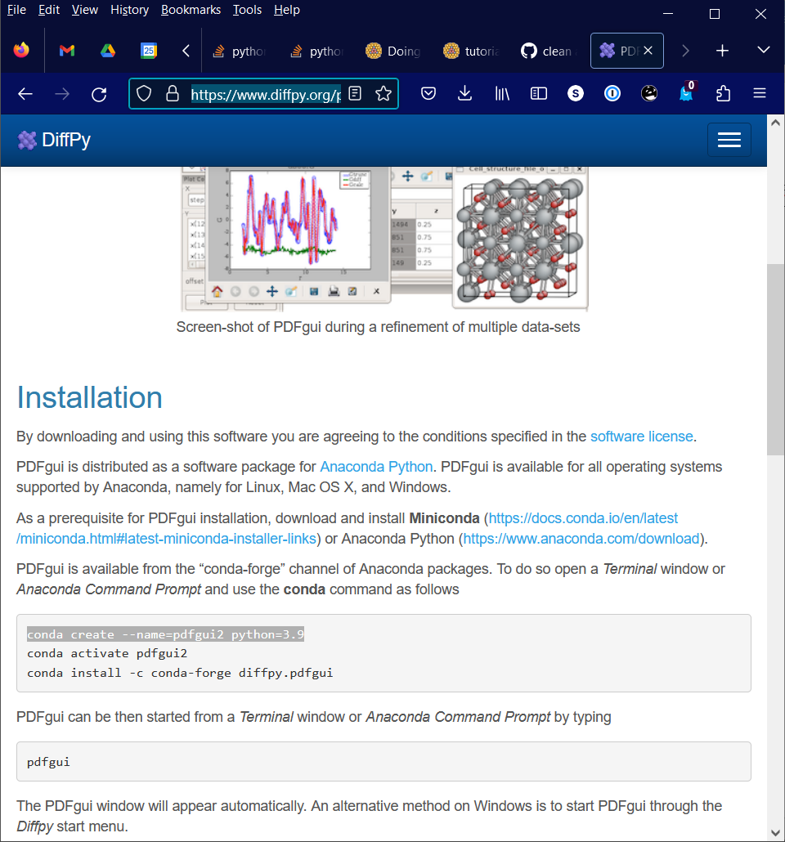
   4. If you do not already have miniconda or Anaconda installed on your computer, we recommend that you download and install miniconda which brings with it the least amount of unwanted software. You can get it here for your platform: <https://docs.conda.io/en/latest/miniconda.html>
   5. If you are working on windows, I have most experience working with the git bash terminal. You may think of installing that too (https://gitforwindows.org/).
2. Next, test that your installation works. These are the steps to run it each time you log on to your computer
   1. Open a new terminal
   2. Activate the conda environment you created to run PDFgui, e.g., : conda activate pdfgui2
   3. Start the program: pdfgui
   4. The GUI should open and you can start using it.
3. Download the examples. These are examples from our upcoming book “Pair Distribution Function Analysis: A primer” that will shortly be available from Oxford University Press. You can obtain them by
   1. Go to <https://github.com/Billingegroup/pdfttp_data>
   2. Click on the green “Code” button
   3. Download the zip file and unpack it (or clone the GitHub repository if you know the GitHub workflow)
4. Test that you have the data. Look for the directory where you unpacked/cloned the data. It should be called pdfttp_data and contain folders such as ch03NiModelling, with one for each chapter of the book. It contains the data and the PDFgui solution for self study (compare your result with that one), but don’t cheat and look at that solution until after the tutorial.